Optimizing Slow Queries with MongoDB’s Tim Kelly (Part One)
Handy Guide for Understanding Slow Performance in MongoDB
Worked through Tim’s awesome video and added links and notes. Performance tuning is an iterative process that involves many factors. Testing should be done in a non-production environment and each setting documented and tested to establish a baseline.
Part 1: Identifying and Diagnosing Slow Queries
Learn how to identify and analyze performance bottlenecks using the profiler, explain() output, and diagnostic tools like MongoDB Atlas Performance Advisor. You’ll walk away knowing how to uncover the “why” behind slow-running operations.
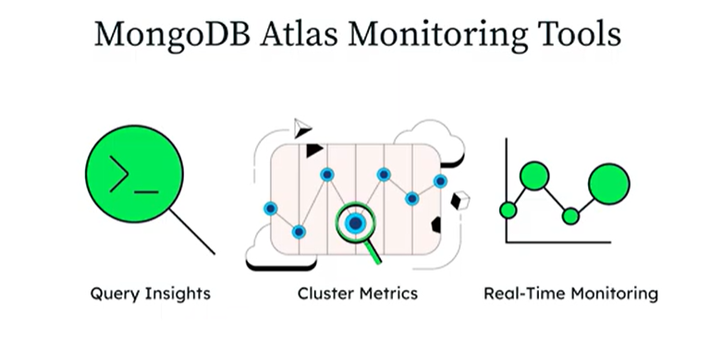
Performance Tools and Techniques in MongoDB
Tim Kelly MongoDB developer advocate delivered the first part of his performance tuning training entitled “Performance Tools and Techniques”.
The methodology for performance tuning in MongoDB involves a structured process of identification, analysis, resource correlation, and iterative optimization.
Performance issues can be with an application, pages load slowly, performance lags and users are frustrated. We can narrow down slow queries and eliminate the application code and network.
Tuning is an iterative process. It is best practice to make incremental tuning changes and test. Making many changes at the same time can make it difficult to find the exact tuning parameter necessary for best performance.

1. Identifying Slow Queries Through Profiling/ Actionable insights
The first step is to profile query data to identify inefficiencies before they cause major disruptions. Profiling helps find long execution times or excessive document scans.
Profiling is especially recommended during testing and development phases and periodically in production.
MongoDB provides two primary profiling tools: the Atlas Query Profiler a graphical tool for M10 or higher managed clusters which analyzes and provide actionable recommendations, and Database Profiler.
Atlas Query Insights show details which include:
Operation Execution Time
Docs Examined
Docs Returned
Examined:Returned Ratio measuring query efficiency
A high Examined:Returned Ratio can mean that no index is being used or MongoDB is scanning may documents but returning few. It can be caused by a poorly designed index.
You can see a demo here:
https://youtu.be/QBNscZeZPcA?t=290
Database Profiler for self-managed instances. Profiling can be set to three levels using the db.setProfilingLevel() setting:
- Level 0: Disabled.
- Level 1: Profiles only "slow" operations exceeding a defined threshold (defaulting to 100 milliseconds).
- Level 2: Profiles all operations (recommended primarily for development due to performance impact).
Example: To query all profiles that took more than 100 milliseconds
db.system.profile.find( {millis: {gt: 100} } ).pretty()
2. Analyzing Query Metrics and Execution Plans
Once slow queries are identified, they must be analyzed using specific performance metrics:
- Execution Time: The total duration spent processing, filtering, and sorting; the common goal is to keep this under 100ms or whatever threshold you chose.
- Examined to Returned Ratio: This measures query efficiency. A 1:1 ratio is ideal; a high ratio indicates the database is scanning many documents to return only a few, suggesting a missing or poor index, the navigational tool for the database.
- Keys Examined: A value of zero indicates that no index was used for the query.
- Explain Command: Running explain("executionStats") provides a detailed breakdown of query stages. A COLLSCAN (collection scan) indicates the database is reading every document, while an IXSCAN (index scan) is the preferred, more efficient method. Full collection scans can be expensive.
In the output below we can see that COLLSCAN is returned meaning the index isn’t used which can cause performance issues.

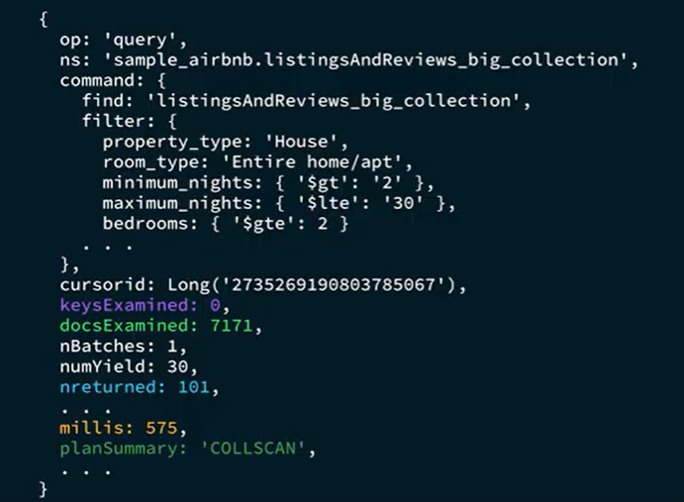

Also check the following:
MongoDB logs - check
Slow query or SLOW_OPERATION
executionTimeMillis
ns
query or filter
Command to check mongodb logs using the jq tool.
grep “Slowquery” /path/to/mongo.log | jq ‘select(.attr.workingMillis > 200)’
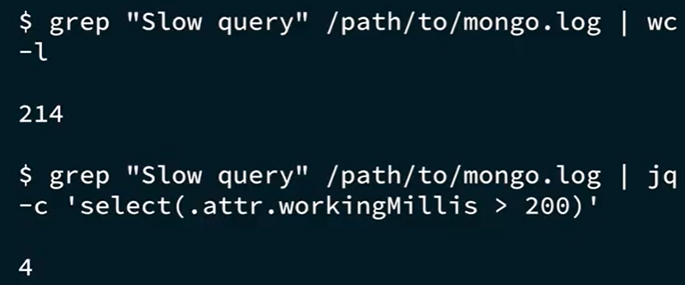

Example using document fields and jq.
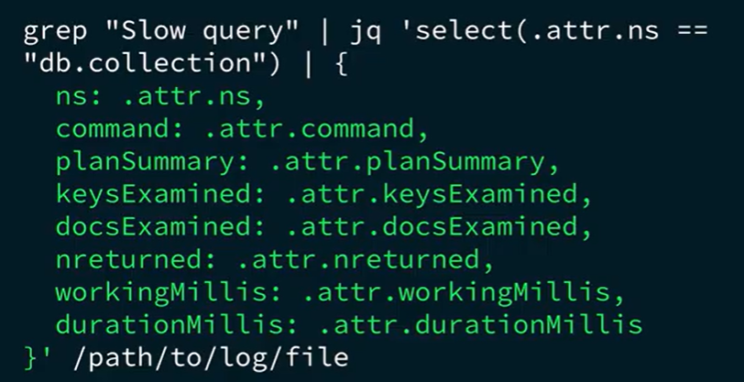
Use the .explain() command.
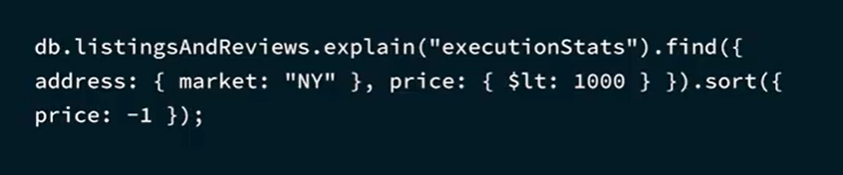
Other problems:
-Collection Scan (COLLSCAN)
-Index Scan (IXSCAN) using the wrong index (verify)
-Sort Stages (Guideline ESR Order Equality, Sort, Range)
https://youtu.be/QBNscZeZPcA?t=921
3. Correlating Queries with System Resources
Performance tuning also requires monitoring hardware saturation, as spikes in CPU, memory, and Disk I/O often correlate with slow queries.
- Memory Management: Insufficient memory forces MongoDB to retrieve data from the disk, which is significantly slower. It can cause CPU saturation and contentions.
- Working Set Size: The goal is to ensure indexes cover most query patterns to reduce the "working set"—the portion of data and indexes frequently accessed in RAM.
- Caching: MongoDB relies on caching to improve performance.
- Monitoring Tools: For deep analysis, administrators use Atlas Real-Time Monitoring or command-line tools like top (to find "hot" collections), mongostat, and htop to identify resource bottlenecks.
4. Implementing and Validating Optimizations
The primary method for resolving slow queries is optimizing the indexing strategy.
- ESR Guideline: When creating compound indexes, follow the Equality, Sort, Range rule to ensure the index is tailored to the fields being matched and sorted.
- Performance Advisor: In Atlas, this tool provides automated recommendations for new indexes and identifies unused ones that may be consuming resources.
- Validation: After adding an index, the explain command should be re-run to confirm that the query now uses an index scan (IXSCAN) and that execution time has decreased.
5. Non Atlas Methods Monitoring Memory Contraints and System Utilization

Tools
Identify bottlenecks and take corrective action using the tools listed below. Remediation can include using indexes, optimizing inefficient queries or hardware upgrades e.g., increasing RAM/disk storage.

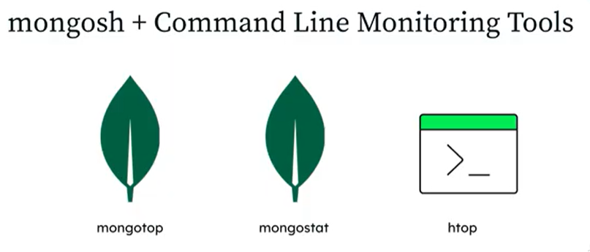
mongotop monitors latency for read and write operations by reporting the time mongodb spends accessing each collection. If a collection is accessed frequently and exhibits high latency then optimizing query filters and indexes can reduce memory usage and improve performance.

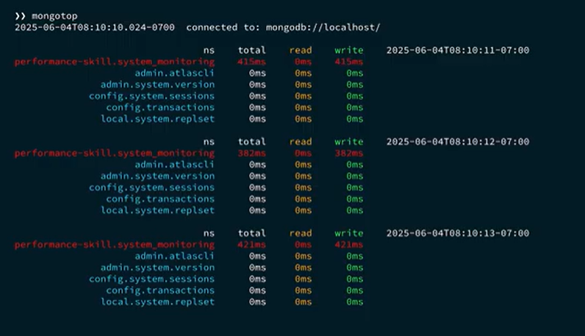

mongostat provides realtime statistics on mongo server activity. The command returns resource activity specific to memory including flushes per second, memory usage and virtual memory usage.
High Flush Rate – system may lack sufficient memory, excessive disk writes. If data and indexes don’t fit in resident memory it means that the database is relying more on disk.
Reliance on Virtual Memory – server swaps data on disk (slower than RAM). Add memory or configure queries to reduce memory usage.
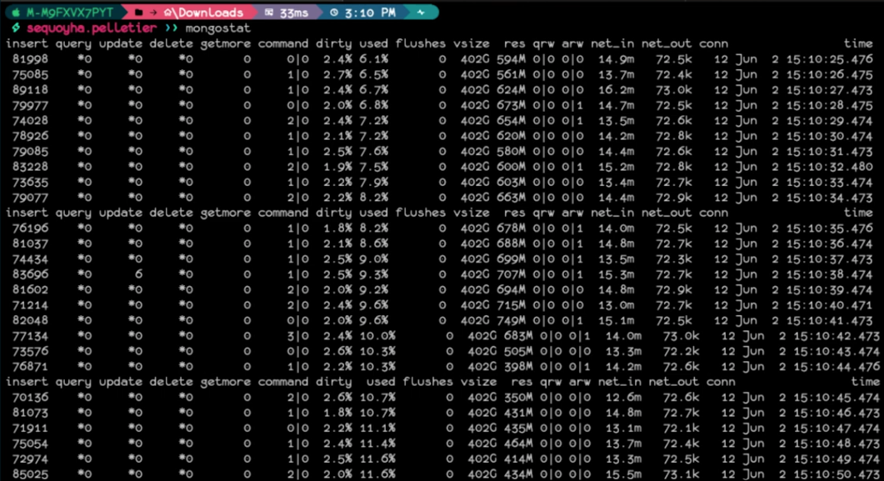

htop resource interactive viewer. For MongoDB, pay close attention to memory, swap and CPU utilization. Check at the holistic level as well as the MongoDB level. Determine if spikes in CPU usage are tied to expensive queries or large workloads. Excessive memory usage can lead to disk swapping and extensive disk I/O. Heavy swapping indicates server is under heavy memory strain requiring additional RAM.

6. Continuous Monitoring and Alerts
Performance tuning is an iterative process because workloads evolve as data and traffic grow. Methodology includes setting up proactive alerts for high memory usage, CPU demand, or I/O bottlenecks to respond before performance degrades. Regular profiling checks should be scheduled post-deployment to ensure that existing optimizations remain effective under changing query patterns. Operational workloads evolve over time:
Workload
Application Features
User Traffic
Data
Changes in these areas may effect query patterns and index alignment. Broader changes in usage may require a more nuanced approach perhaps involving compounded indexes for multifield queries or unique indexes to enforce data constraints.
Enabling the database profiler can offer insights.
db.setProfilingLevel(1, 150)
Profiling can also confirm the effectiveness of the changes by comparing the before and after reports.

Atlas offers a Performance Advisor the provides actionable analysis.
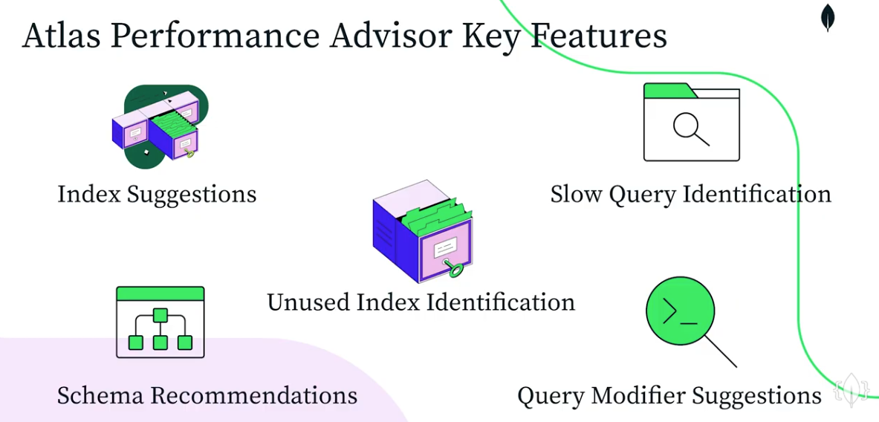

Atlas can create indexes that can be tested in non-production environments.
Using explain can assist in evaluating the query by checking the executionTimeMillis.
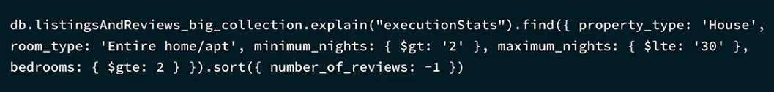

Indexes can also be created, checked, hidden and dropped using the MongoDB shell.
db.users.createIndex({ email: 1, status: 1})
db.users.getIndexes()
db.users.hideIndex(“email_1”) # “hide” an index for testing
db.users.dropIndex(“email_1”)

Resources
https://www.mongodb.com/resources/products/capabilities/webinar-mongodb-query-performance-optimization
https://www.youtube.com/watch?v=QBNscZeZPcA (Full Presentation ~ 29 mins)
https://www.mongodb.com/resources/products/capabilities/webinar-mongodb-query-performance-optimization
MongoDB Query Optimization

Useful Links
MongoDB main YouTube channel: / @mongodb
Website: https://mdb.link/MongoDBYT
LinkedIn:  / mongodbinc
MongoDB Developer Blog: https://mdb.link/developerblogYT
https://www.youtube.com/@MongoDBDevelopers

